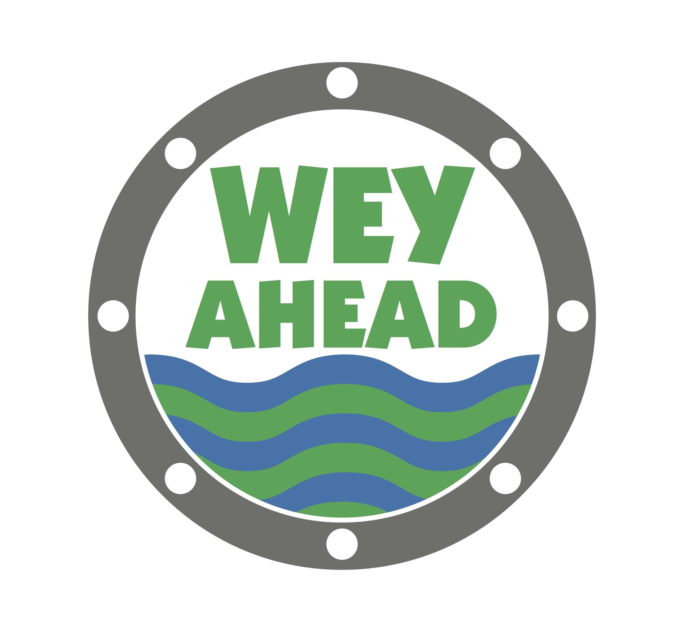
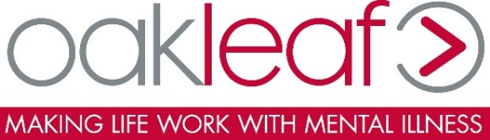

Wey Ahead
19 May 2018
Jubilee Square, Woking, Surrey GU21 6YG
http://aat-events.com/race/wey-ahead/
Multi-award winning race organisers aat-events have just launched Surrey’s largest walk / run event to raise awareness and funds for local mental health charities. Mental health is a growing concern in today’s society; affecting approximately 1 in 4 people in the UK.
Starting from Jubilee Square in the heart of Woking Town Centre, hundreds will walk or run along the Basingstoke Canal to Byfleet (4.5km), Guildford (25km) or Godalming (32km) to raise money for Status Employment, CornerHouse, Hear Us, Oakleaf and Happy Steps.
The choice to walk or run at this fundraising event offers participants of all ages and abilities the freedom to join in and show their support for this fantastic cause. The 4.5km makes an excellent choice for young families and the elderly; and regular runners will enjoy the challenge of running from Woking to Guildford or Godalming. Those who do continue on from Byfleet will follow the River Wey down past a number of golf courses to the bottom of Guildford high-street. Participants finishing here could celebrate their achievements over coffee at a boutique coffee shop on Guildford’s infamous cobbled high-street, or even enjoy a pub lunch by the river. 32km walkers and runners will continue to follow the towpath behind Shalford Park to St Catherine’s Lock, until they reach the beautiful Phillips Memorial Park in the heart of Godalming. No matter where participants choose to finish, the event is well connected by train. The start line is just a short walk from Woking Station; and frequent train services run back to Woking from Byfleet, Guildford and Godalming stations.
Proceeds from Wey Ahead will be donated to Status Employment, CornerHouse, Hear Us, Oakleaf and Happy Steps; participants are welcome to raise additional funds.
The Mercer Surrey Half Marathon - which is also delivered by aat-events - raises £0.4 million for national and local charities every year. aat’s Hogs Back Road Race raised over £1000 for their charity partner in December 2017.
Enter: https://www.riderhq.com/events/75989/wey-ahead/enter

