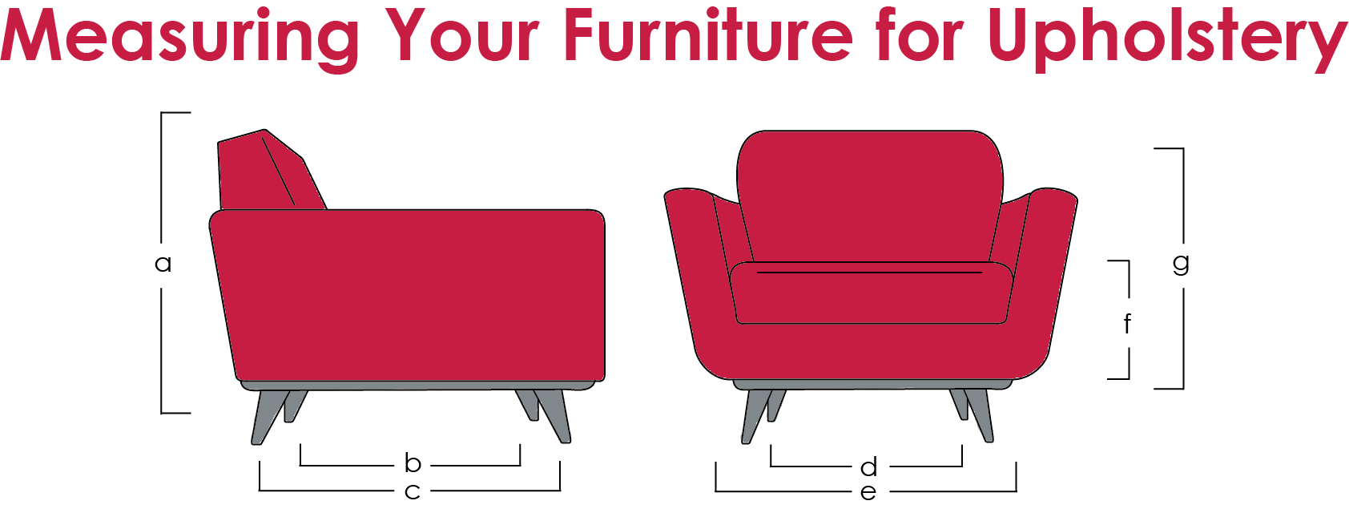

(a) Height: ? cm (? in) (e) Width: ? cm (? in)
(b) Seat depth: ? cm (? in) (f) Seat Height: ? cm (? in)
(c) Depth: ? cm (? in) (g) Arm Height: ? cm (? in)
(d) Seat Width: ? cm (? in)

For fabric choices please see;
http://www.linwoodfabric.com/product-category/fabrics/
OR
www.romo.com/collections
and tell us the product code, colour and design

